UNITED STATES DISTRICT COURT EASTERN DISTRICT OF TEXAS
BEAUMONT DIVISION

CHRISTOPHER VICKERS, §
§
Plaintiff(s), §
 | §
v. | § | No.
 | § | Jury
BISON SPECIALITY SERVICES, | §
LLC, | §
 | §
Defendant(s). | §

PLAINTIFF’S ORIGINAL COMPLAINT

Plaintiff Christopher Vickers (referred to as “Vickers”) brings this action against Defendant Bison Specialty Services, LLC (referred to as “Bison Specialty”) under Title VII of the Civil Rights Act of 1964, 42 U.S.C. §§ 2000e-2000e-17, (“Title VII”) and Texas Labor Code, §§ 21.051 and 21.055 (“Tex. Labor Code”) to recover back pay, front pay, compensatory damages, exemplary damages, attorney’s fees, plus interest and costs.

Nature of Suit

- Vickers’ claims arise under Title VII and Texas Labor Code.

- Title VII was enacted to improve the economic and social conditions of minorities and women and to prohibit discrimination in employment on grounds of race, color, religion, sex, and national origin. See, 29 C.F.R. § 1608.1(b).

- Bison Specialty violated Title VII and Texas Labor Code by discriminating against him on the basis of race (African American) and by retaliating against him for opposing unlawful employment practices and/or for making charges, testifying, assisting and/or participating in an investigation, proceeding, or hearing under Title VII and Texas Labor Code.

Jurisdiction & Venue

- This action arises under a federal statute, Title VII. 28 U.S.C. § 1331 (federal-question jurisdiction).
- This Court has supplemental subject matter jurisdiction over the §§ 21.051 and 21.055, because the state law claims arise from a common nucleus of operative facts with the federal claims and are so related to the federal claims that they form part of the same case or controversy under Article III of the United States Constitution. 28
U.S.C. §1367

- Venue is proper in this district and division because Vickers resides in this district and division. 28 U.S.C. § 1391(b)(1).

Parties

- Vicker is an individual who resides in Orange County, Texas and who was employed by Bison Specialty.

- Defendant Bison Specialty Services, LLC is a Texas limited company that may be served with process by serving its registered agent:
Donald Westley Thomas III 409 S. Carancahua
Corpus Christi, Texas 78401

Alternatively, if the registered agent of Bison Specialty Services, LLC cannot with reasonable diligence be found at the company’s registered office, Bison Specialty Services, LLC may be served with process by serving the Texas Secretary of State pursuant to TEX. BUS. ORG. CODE § 5.251 and TEX. CIV. PRAC. & REM. CODE § 17.026.
- An allegation that Bison Specialty committed any act or omission should be construed to mean the company’s officers, directors, vice-principals, agents, servants or employees committed such act or omission and that, at the time such act or omission was committed, it was done with the full authorization, ratification or approval of Bison Specialty or was done in the normal course and scope of employment of Bison Specialty’s officers, directors, vice-principals, agents, servants or employees.

Facts

- Bison Specialty provides turnaround and maintenance solutions to the refining and petrochemical, energy infrastructure, and power industries.
- Bison is engaged in an industry affecting commerce.

- For each working day during each of twenty or more calendar weeks during each calendar year that Bison Specialty employed Vickers (or in the calendar year preceding their employment), Bison Specialty had fifteen or more employees.
- Bison Specialty does business in the territorial jurisdiction of this Court.

- Vickers, an African American, was employed with Bison Specialty from approximately September 14, 2018 to March 30, 2021 at its location in Beaumont, Texas.
- Chad Luhan (“Luhan”), Caucasian, is a president and member of Bison Specialty.
- Josh Hall (“Hall”), Caucasian, was a general foreman during the relevant times that Vickers was employed with Bison Specialty.
- Albert Leblanc (“Leblanc”), Caucasian, was a shop supervisor during the relevant times that Vickers was employed with Bison Specialty.
- During Mr. Vickers’ employment, Mr. Leblanc, was his supervisor.

- LeBlanc has a habit of making jokes about people of color, including African Americans.
- He described African Americans as lazy.

- Further, he often bragged about living in Vidor, Texas, referring to it as “God’s country”, because mostly only Caucasian people live there.

- Leblanc made it known to employees that he has friends in the Aryan Brotherhood, a white supremacist gang.
- According to at least one witness, Mr. Leblanc and white employees fed off of each other’s laughter concerning jokes about African Americans.
- Mr. Leblanc’s racial harassment towards Vickers was frequent and offensive.
- Mr. Leblanc publicized his racist remarks in group messages he sent to employees, including subordinates.
- For example, LeBlanc sent a video of African Americans dancing on the freeway, with the song in the background with the lyrics, “Go back to Africa”.
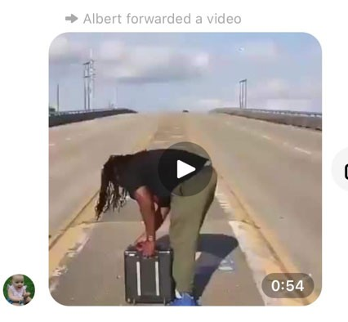

- Another video LeBlance publicized showed two African American males, with one instantly turning Caucasian and telling the other African American, “Naw Ni**a, go get a job!”
- In the months after George Floyd’s murder, Defendant’s supervisor, LeBlanc, circulated another racially derogatory message:
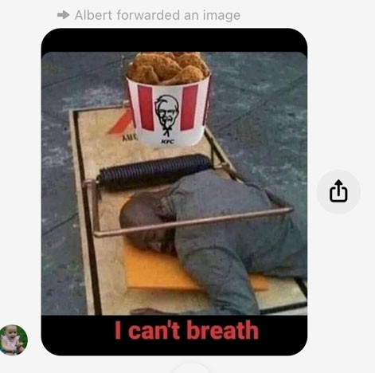
- In addition, Bison Specialty exhibited preferential treatment to its Caucasian employees.
- Caucasian employees were allowed to park in the front of the facility and bring firearms to the property.

- Mr. Vickers complained to Bison Specialty’s human resources representative and to Josh Hall, the general foreman, about Leblanc’s discriminatory treatment.
- Mr. Hall’s response was that he understood that Mr. Leblanc’s racist behavior was an issue, but that he could not do anything about him.
- In addition Mr. Chad Luhan, president and member of Bison Specialty Services received Mr. Leblanc’s complaints.
- Unfortunately, in late February and early March of 2021, during the height of the Covid-19 Pandemic, Mr. Vickers and his family were stricken with the virus, including his wife and son.
- He notified Bison Specialty but received an order from Chad Luhan, Bison Specialty’s president, to return to work regardless of his diagnosis, despite the company’s Covid protocols prohibiting him from returning to work.
- While Mr. Vickers and his family were recovering from Covid-19 and following his complaints of racial discrimination and hostile work environment, Bison Specialty terminated him.
- Ultimately Bison Specialty discharged Vickers for engaging in protected activity (specifically, complaining about unlawful discrimination in the workplace).

- As a result of Bison Specialty’s unlawful conduct, Vickers has suffered and will continue to suffer damages in the form of back pay, front pay, lost fringe benefits, compensatory damages for future pecuniary losses, emotional pain, suffering, inconvenience, mental anguish, loss of enjoyment of life, and other non-pecuniary losses.

Count One—Race Discrimination and Hostile Work Environment in Violation of Title VII
(Vickers)
- Vickers adopts by reference all of the facts set forth above. See, Fed. R. Civ. P. 10(c).
- An employer commits an unlawful employment practice if it “fail[s] or refuse[s] to hire or discharge[s] any individual, or otherwise … discriminate[s] against any individual with respect to his [or her] compensation, terms, conditions, or privileges of employment, because of such individual’s … race[.]” 42 U.S.C. § 2000e-2(a)(1).
- Bison Specialty, through its employees, including supervisors, subjected Vickers to racial slurs, racial jokes, epithets, sent racist text messages as well as exhibited preferential treatment to its non-African American employees.
- Bison Specialty perpetuated and allowed a hostile work environment towards Vickers.
- For example, Leblanc often commented that African Americans were “lazy blue gum ni**ers” and called African American employees “ni**ers”.

- As a result of Bison Specialty’s unlawful conduct, Vickers has suffered and will continue to suffer damages in the form of back pay, front pay, lost fringe benefits, compensatory damages for future pecuniary losses, emotional pain, suffering, inconvenience, mental anguish, loss of enjoyment of life, and other non-pecuniary losses.

Count Two— Retaliation in Violation of Title VII (Vickers)
- Vickers adopts by reference all of the facts set forth above. See, Fed. R. Civ. P. 10(c).
- An employer commits an unlawful employment practice if it “discriminate[s] against any of his employees or applicants for employment … because he [or she] has opposed any practice made an unlawful employment practice by [Title VII], or because he has made a charge, testified, assisted, or participated in any manner in an investigation, proceeding, or hearing under [Title VII].” 42 U.S.C. § 2000e-3(a).
- Bison Specialty doubled down on its discriminatory treatment of Vickers (by, for example, terminating him immediately following his last complaint of discrimination and hostile work environment, citing that Vickers had abandoned his job because he couldn’t come to work when he and his family were ill with Covid-19) about the discriminatory treatment.

- As a result of Bison Specialty’s unlawful conduct, Vickers has suffered and will continue to suffer damages in the form of back pay, front pay, lost fringe benefits, compensatory damages for future pecuniary losses, emotional pain, suffering, inconvenience, mental anguish, loss of enjoyment of life, and other non-pecuniary losses.

Count Three —Racial Discrimination and Hostile Work Environment in Violation of Tex. Labor Code § 21.051
(Vickers)

- Vickers adopts by reference all of the facts set forth above. See, Fed. R. Civ. P. 10(c).
- “An employer commits an unlawful employment practice if because of race[] … the employer[] … discharges an individual, or discriminates in any other manner against an individual in connection with compensation or the terms, conditions, or privileges of employment[.]” Tex. Labor Code § 21.051(1).
- Bison Specialty, through its employees, including supervisors, subjected Vickers to racial slurs, racial jokes, epithets, sent racist text messages as well as exhibited preferential treatment to its non-African American employees.
- Bison Specialty perpetuated and allowed a hostile work environment towards Vickers.

- For example, Leblanc often commented that African Americans were “lazy blue gum ni**ers” called African American employees “ni**ers”.
- As a result of Bison Specialty’s unlawful conduct, Vickers has suffered and will continue to suffer damages in the form of back pay, front pay, lost fringe benefits, compensatory damages for future pecuniary losses, emotional pain, suffering, inconvenience, mental anguish, loss of enjoyment of life, and other non-pecuniary losses.

Count Four—Retaliation in Violation of Tex. Labor Code § 21.055
(Vickers)

- Vickers adopts by reference all of the facts set forth above. See, Fed. R. Civ. P. 10(c).
- “An employer commits an unlawful employment practice if the employer[] … retaliates or discriminates against a person who[] … (1) makes or opposes a discriminatory practice; (2) makes or files a charge; (3) files a complaint; or (4) testifies, assists, participates in any manner in an investigation, proceeding, or hearing.” Tex. Labor Code § 21.055.
- Bison Specialty doubled down on its discriminatory treatment of Vickers (by, for example, terminating him immediately following his last complaint of discrimination and hostile work environment, citing that Vickers had abandoned his job

because he couldn’t come to work when he and his family were ill with Covid-19) about the discriminatory treatment.
- As a result of Bison Specialty’s unlawful conduct, Vickers has suffered and will continue to suffer damages in the form of back pay, front pay, lost fringe benefits, compensatory damages for future pecuniary losses, emotional pain, suffering, inconvenience, mental anguish, loss of enjoyment of life, and other non-pecuniary losses.

Exemplary Damages

- Vickers adopts by reference all of the facts set forth above. See, Fed. R. Civ. P. 10(c).
- Bison Specialty engaged in the unlawful discrimination and retaliation described above with malice and with reckless indifference Vickers’s rights.
- Accordingly, Vickers should be awarded exemplary damages against Bison Specialty in an amount appropriate to deter similar future misconduct.

Attorney’s Fees

- Vickers adopts by reference all of the facts set forth above. See, Fed. R. Civ. P. 10(c).
- Vickers is entitled to recover reasonable and necessary attorney’s fees by statute. 42 U.S.C. § 2000e-5(k).

- Vickers has retained the professional services of the undersigned attorneys.
- Vickers has complied with the conditions precedent to recovering attorney’s fees.
- Vickers has incurred or may incur attorney’s fees in bringing this lawsuit.

- The attorney’s fees incurred or that may be incurred by Vickers was or will be reasonable and necessary.

Jury Demand

- Vickers demands a trial by jury on all issues triable to a jury.

Administrative Prerequisites

- On June 1, 2021, Vickers filed a charge of discrimination with the Equal Employment Opportunity Commission.
- On February 1, 2022, Vickers received a notice of right to sue from the Equal Employment Opportunity Commission.
- Vickers brought this action within 90 days of receiving the notices of right

to sue.

- On June 1, 2021, Vickers filed a charge of discrimination with the Texas Workforce Commission.

- On March 1, 2022, Vickers received a notice of the right to file a civil action from the Texas Workforce Commission.
- Vickers brought this action within 60 days of receiving the notices of the right to file a civil action.
- Vickers has exhausted all administrative prerequisites to bringing this action.

Conditions Precedent

- All conditions precedent to Vickers’ claims for relief have been performed or have occurred. See, Fed. R. Civ. P. 9(c).

Relief Sought

- Vickers demands:

  - direct or general damages;

  - back pay, plus prejudgment interest as provided by law, from the date of any adverse employment action until the date of judgment;

  - an award of the present value of front pay due to them for a reasonable period following the date of the judgment, calculated as of the date of judgment;

  - additional compensatory damages in an amount within the jurisdiction of this court;

  - exemplary damages against Bison Specialty in a sum determined by the trier of fact;

  - all prejudgment and postjudgment interest allowed by law;

  - attorney’s fees;

  - costs of court;

  - all other relief to which Vickers is entitled.

Respectfully Submitted, MOORE & ASSOCIATES
Lyric Centre
440 Louisiana Street | Suite 1110
Houston, Texas 77002-1055
Telephone: (713) 222-6775
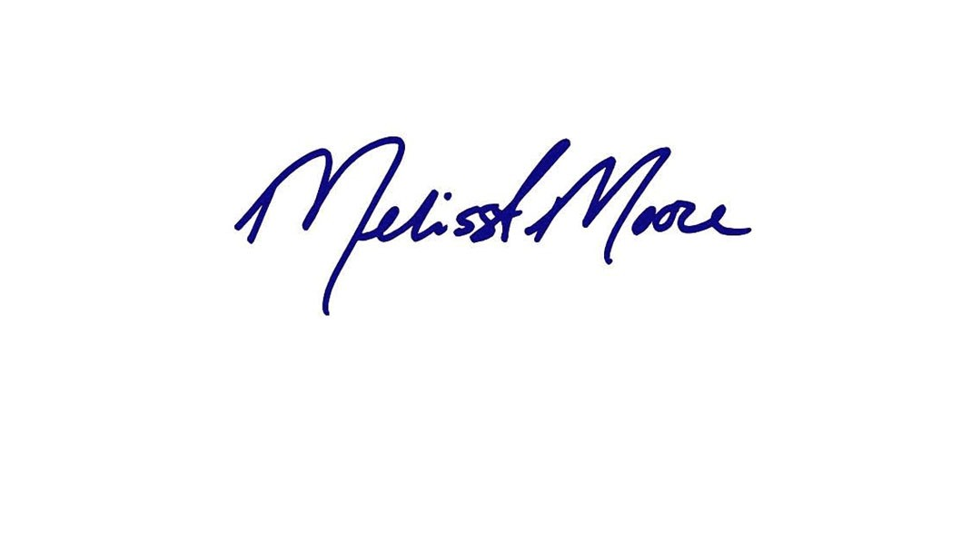
Facsimile: (713) 222-6739

By: Melissa Moore
Tex. Bar No. 24013189
melissa@mooreandassociates.net Rochelle Owens
Tex. Bar No. 24048704
rochelle@mooreandassociates.net

ATTORNEYS FOR PLAINTIFF

